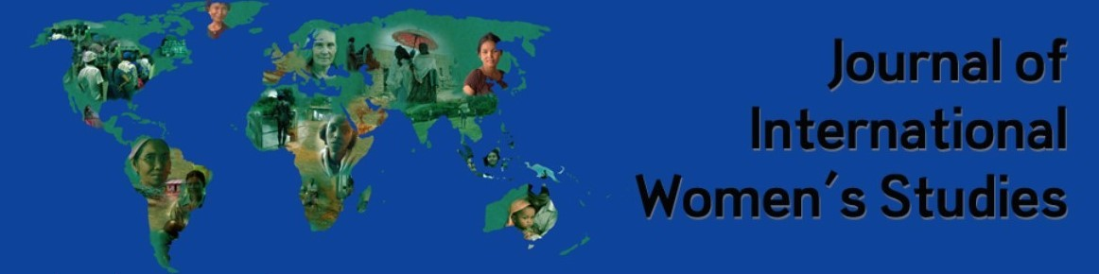
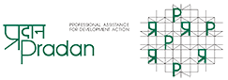
Call for Papers: Joint Special issue—Journal of International Women’s Studies (JIWS) and Professional Assistance for Development Action (PRADAN)
Indigenous and Tribal Communities, Gender, and Women: A Comparative Global Perspective with a Focus on India

Indigenous and Tribal communities globally are enormously diverse and heterogeneous with wide-ranging differences among them regarding language, physical characteristics, demographic traits, modes of livelihood, and the treatment and position of women. In India, state governments identify tribal communities as Scheduled Tribes (STs) using the provision of the constitution of India to foster their educational, economic, social and other empowerment. STs form about 8.6% of India’s population.
The constitution also makes explicit provisions for making a financial allocation to States towards that end. Several programs have been formulated and implemented by the union and many state governments to promote the welfare of tribal people Many welfare activities have been taken up by the government and other organisations with or without this financial aid. These activities themselves come with a certain value system and ideas of welfare and development which invariably have effects on tribal life and livelihoods.
Indigenous and Tribal communities in India and worldwide, have been subjected to displacement and dispossession supported by laws for the setting up of mining or mining-related industries and resource extraction in general; construction of large dams, establishing wildlife sanctuaries, and the like.
In this special issue, we ask: what is known about how these changes have affected the lives of women? Given the heterogeneity and, the transformations that have been taking place, it is difficult to generalise the position of women across tribal societies globally, including India.
In view of the above, the JIWS in collaboration with PRADAN, seeks papers for this Special Issue to evaluate critically women’s position in different tribal societies worldwide, although with a focus on India in particular, given PRADAN’s area of work.
Topics:
We seek scholarly articles, feminist reflections, book and film reviews (please see the JIWS’ Policies and Submissions page for details on these genres here: https://vc.bridgew.edu/jiws/policies.html ) that address the following topics with specific focus on tribal communities. We are particularly interested in contributions from tribal women:
Critical examination of the concept of “tribes and indigeneity” through a decolonial lens
Women’s leadership
Challenges, precarity and vulnerability
Changing gender roles and beliefs systems pertaining to women and gender
Social determinant of health—physical and psychological
Youth education, empowerment, and activism
Climate crisis, innovations and vulnerabilities
Resource conservation
View of nature, cosmology, belief systems
Dynamics of interactions with NGOs and/or governments at the state, nation-state and international levels
Sexuality and gender diversity
Masculinity, changing norms and hopeful partnerships
Domestic violence
Decision-making processes

The Journal of International Women’s Studies is an online, open-access, peer-reviewed feminist journal that provides a forum for scholars, activists, and students to explore the relationships among theories of gender and sexuality and various forms of organizing and critical practice. The journal seeks both multidisciplinary and cross-cultural perspectives, and invites submissions in the form of scholarly articles, essays, book reviews, and works of fiction. In addition, the Journal supports multi-media submissions through streaming audio capability, embedded video, and links to video sites to display short films and other visual materials. The JIWS is currently indexed with the Library of Congress. The ISSN assignment for “Journal of International Women’s Studies” is ISSN 1539-8706. https://vc.bridgew.edu/jiws/
PRADAN is one of the premier NGOs working on poverty alleviation in India. Young professionals from reputed institutions join PRADAN to engage with economically deprived communities at the grassroots by strengthening community institutions, building social capital and supporting local leadership to take charge of their own development. Basis our programs and pilots impacting ~9,34,732 rural households’, more than half of which are tribals, prototypes have been developed for wide-scale replication. https://www.pradan.net/

DATES and Submission emails
Submission Date: November 30, 2022
Anticipated publication date: August-September 2023.
Please send the manuscripts of your original article or feminist reflection to Parijat Ghosh, parijatghosh@pradan.net. In the subject line type: JIWS-PRADAN special issue.
Please send your film reviews to: Khumo Pone, khumopone@gmail.com OR Mohosin Mandal, mandalmohosin1@gmail.com In the subject line type: JIWS-PRADAN special issue.
Please send your book reviews to: Madhavi Venkatesan, m.venkatesan@northeastern.edu
In the subject line type: JIWS-PRADAN special issue

