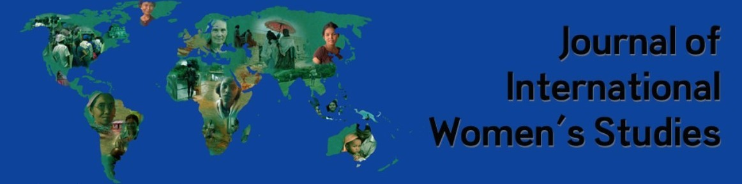
Call for Papers: Journal of International Women’s Studies (https://vc.bridgew.edu/jiws/)
Special Issue:
Empowering Women and Girls Living with Disabilities in the Arab States: Challenges and Opportunities

People with disabilities are a key component of the international human development process. According to global statistics, women with disabilities account for 10% of all females on the planet. The world and the Arab region have witnessed a great positive transformation in the status of women and girls living with disabilities, and it has become clear that changing the social perception of women with disabilities internationally and the role of laws and legislation have had a positive impact on the status, position, role, and integration of women in Arab states. Disabilities include both physical and psychological domains that affect day-to-day functioning. People with disabilities may be affected by the limitations of the healthcare system; environmental factors such as climate-anxiety, transportation and architectural design of buildings; educational and employment factors; and other barriers to inclusion such as social stigma. Women and girls with disabilities have additional barriers in their socio-economic participation compared to men and boys with disabilities and those who do not have disabilities.
Generally, the concept of empowerment is considered an important element in achieving gender balance and social justice. Feminism explains the dynamics of unequal power distribution between men and women. Shared concepts of empowerment and Feminism are critical self-awareness, collective action, conscientization (self-reflection in relation to society), and remedying unequal access to power and resources. Papers must engage with empowerment theory vis-à-vis global feminist and disability theorizing to address the ways discourses of empowerment can be transformative of social system.

The purpose of this Special Issue is to examine how women and girls experience Arab states, as well as the legislative and programmatic efforts made to eliminate barriers to their full societal participation. This special issue highlights the unique challenges and opportunities experienced by women and girls with disabilities. This special issue is expected to be useful for advocacy and future project planning for donors; NGOs; UN agencies; media; women, and youth organizations.
We welcome manuscripts that include but are not limited to the following aspects and their relevance to women and girls living with disabilities:
- The role of organizations serving women and/or girls with disabilities and how regional and international organizations empower them.
- Adaptive products that empower women and girls to increase or achieve self-reliance.
- Lived experiences of women and girls with disabilities
- Relations and collaborations between Arab countries that support women and girls with disabilities.
- Employment of women and girls with disabilities in private and public settings.
- Elimination of social stigma related to women and girls with disabilities.
- Enhancement of public participation by women with disabilities
- Use of media in a way that empowers women and girls with disabilities
- Improvement of environmental access using universal design in the architecture of public and private facilities
- Experiences of war on women and girls with disabilities
- Crimes against women with disabilities: successfully moving forward
- Ending violence and abuse of women and girls with disabilities.
- Social challenges and opportunities for women with disabilities (family solidarity, divorce, custody, marriage, parenting, etc.)
- The economic impacts on growth, equity, distribution of resources, job losses, etc.
- Healthcare challenges: Issues of access to both physical and psychiatric health care
- Education and its challenges: Approaches that empower and support successful education of women and girls with disabilities.
- Experiences of women and girls with disabilities after Covid 19
- Entrepreneurship for women with disabilities
- Volunteering with women and girls with disabilities.
- Proposed legislation, laws, and social policy that support the inconclusiveness of women and girls with disabilities in society.
- Elder women with disabilities
- And any other topic related to the empowerment of women and girls with disabilities.
Paper Guidelines: Submissions to the Special Issue are governed by the guidelines of the JIWS that can be found at: https://vc.bridgew.edu/jiws/policies.html#guidelines. “Your article and all information should be in Times New Roman 12 font, single-spaced; left/right-justified; bold topic headings with no space between heading and paragraph including title, abstract, and author's name/s; two spaces between the author’s name/s and abstract. italicized subheadings (no numbers). Keywords should be italicized with the three (or more) key phrases or words themselves should not be in italics. Follow APA or MLA citation styles, or a style appropriate to your discipline; references/bibliographies, which should be single-spaced. Articles that do NOT conform to submission guidelines will be automatically rejected. Authors should consult recent editions for guidelines and send inquiries to the editor. Please note: this does not refer to your final draft, but to the final version of your article once it is revised and resubmitted. Improperly formatted articles will be sent back to the authors and must be received by the publication date to be included in the designated issue.”
Length: papers should be between 7000 and 9000 words.
The deadline for submission of papers is December 18, 2022, or earlier. We anticipate the publication date is to be the Summer of 2023.
Contact and submission email: rihssspecialissue@sharjah.ac.ae
Special Issue Editors:
- Prof. Fakir Gharaibeh, Research Institute of Humanities and Social Sciences, University of Sharjah, United Arab Emirates.
- Dr. Laura Gibson, Marilyn Younger Conley School of Social Work
Brescia University, USA.

